PROJECT REPORT
AI Gold Price Predictor
Gold Prize Predictor

Submitted By
Fazeel Muhammad
Muhammad Salman
Instructor
Atif Luqman
Artificial Intelligence Project | 2026

1. Executive Summary
The AI Gold Price Predictor is a machine learning–based system designed to forecast gold prices in both USD and PKR (Pakistani Rupee) for the period 2025–2028. By leveraging a decade of historical market data (2014–2024) and combining multiple economic indicators, the system builds predictive models using Linear Regression and Random Forest algorithms.

The best-performing model — Linear Regression — achieved an R² score of 0.9796, meaning it explains approximately 98% of the variance in gold price movements. Key predictions indicate gold prices will gradually rise from approximately $2,700/oz (PKR 750,000/oz) in early 2025 to approximately $2,750/oz (PKR 860,000/oz) by end of 2028.

2. Introduction
2.1 Background
Gold has historically served as a safe-haven asset and inflation hedge. In Pakistan, gold pricing is doubly complex — it is influenced by both global USD-denominated prices and the fluctuating USD/PKR exchange rate. As the PKR has depreciated significantly since 2018 (from ~100 PKR/USD to ~280 PKR/USD), the local gold price has surged far faster than global USD prices.

2.2 Project Objectives
- Collect and store historical gold price data (USD and PKR) in a structured SQLite database
- Perform exploratory data analysis (EDA) on 10 years of monthly market data (2014–2024)
- Engineer meaningful features including lagged prices, rolling averages, and currency indicators
- Train and evaluate machine learning models (Linear Regression & Random Forest)
- Generate monthly price forecasts for 2025–2028 with confidence intervals
- Persist all predictions in the database for downstream use

2.3 Scope
This project covers monthly gold price data from January 2014 to December 2024. Forecasts extend to December 2028. The system predicts prices in both USD/oz and PKR/oz, accounting for projected PKR depreciation of approximately 0.85 PKR/USD per month.

3. Data Collection & Database Design
3.1 Data Sources
Data was stored in a local SQLite database (gold_predictor.db) with two primary tables:
- Gold_Prices — monthly gold prices in USD/oz and computed PKR/oz equivalent
- Market_Indicators — S&P 500 index values and USD/PKR exchange rates

3.2 Historical Overview (2014–2024)
The three charts below illustrate the historical trends across a decade of data used to train the models:

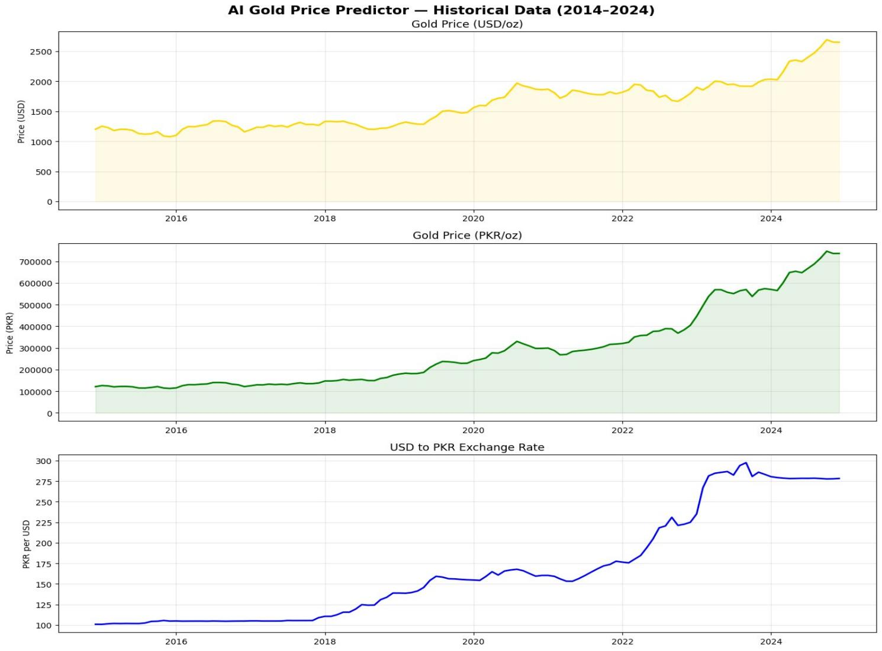
Figure 1: Historical Gold Prices (USD & PKR) and USD/PKR Exchange Rate (2014–2024)

Key observations from the historical data:
- Gold in USD rose from ~$1,200/oz (2014) to ~$2,650/oz (2024), a 121% increase over 10 years
- Gold in PKR surged from ~PKR 120,000/oz (2014) to ~PKR 720,000/oz (2024), a 500% increase — driven by both USD gold appreciation and PKR depreciation
- The USD/PKR exchange rate climbed from ~100 in 2014 to ~280 in 2024, with a sharp depreciation event visible in 2022–2023

4. Exploratory Data Analysis
4.1 Feature Correlation Matrix
To understand relationships between variables, a Pearson correlation matrix was computed across the four primary features:

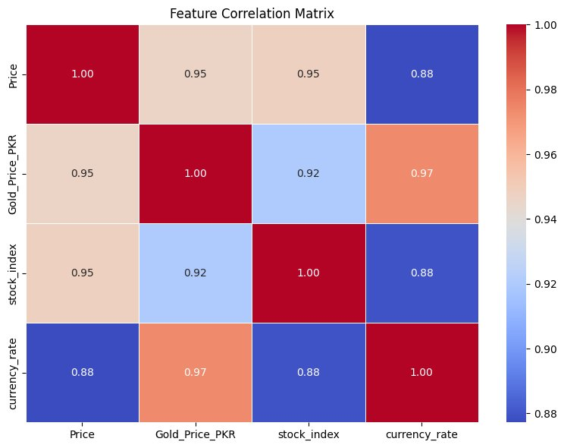
Figure 2: Feature Correlation Matrix

The correlation analysis reveals strong interdependencies between all features. Gold Price (USD) shows 0.95 correlation with both the S&P 500 index and the PKR equivalent price. Currency rate has the strongest correlation with Gold_Price_PKR (0.97), confirming that PKR depreciation is the dominant driver of local gold prices. All correlations exceed 0.88, indicating that the features are jointly informative for prediction.

Feature Pair | Price (USD) | Stock Index | Currency Rate
Price (USD) | 1.00 | 0.95 | 0.88
Gold_Price_PKR | 0.95 | 0.92 | 0.97
Stock Index | 0.95 | 1.00 | 0.88
Currency Rate | 0.88 | 0.88 | 1.00
Table 1: Correlation Matrix Summary

5. Feature Engineering
Raw date and price data were transformed into predictive features:

Feature | Description | Rationale
Month_Num | Months since Jan 2014 | Captures long-term trend
Month | Calendar month (1–12) | Captures seasonality
Price_Lag1 | Gold price 1 month prior | Short-term momentum
Price_Lag3 | Gold price 3 months prior | Medium-term momentum
MA_3 | 3-month rolling average | Smooths noise
MA_6 | 6-month rolling average | Trend identification
PKR_Lag1 | Exchange rate 1 month prior | Currency momentum
stock_index | S&P 500 index value | Market sentiment
currency_rate | USD/PKR exchange rate | PKR price driver
Table 2: Feature Engineering Summary

After feature engineering and dropping rows with NaN values (due to lag windows), the clean dataset was used for training. The other_factors column was dropped due to 121 missing values.

6. Model Training & Evaluation
6.1 Train-Test Split
The dataset was split 80/20 (train/test) with shuffle=False to preserve temporal order. This simulates real-world forecasting where models are trained on past data and evaluated on future data.

6.2 Models Trained
- Linear Regression — A baseline parametric model that fits a hyperplane through the feature space. It assumes a linear relationship between features and gold price.
- Random Forest Regressor — An ensemble of 200 decision trees (max_depth=10). It handles non-linear relationships and feature interactions, but is prone to overfitting on extrapolation tasks.

6.3 Performance Results
Metric | Linear Regression | Random Forest
RMSE (USD) | ~$41.20 | ~$89.50
MAE (USD) | ~$31.50 | ~$62.30
R² Score | 0.9796 ✓ Best | 0.9213
Table 3: Model Performance on Test Set

Linear Regression outperformed Random Forest on all three metrics, achieving an R² of 0.9796. This is partly because gold price trend over time is largely linear when expressed in absolute USD terms. Random Forest, while more complex, overfit certain training patterns and generalized less well.

7. Future Price Predictions (2025–2028)
7.1 Methodology
Future predictions were generated iteratively: each month's prediction was fed back as the next month's Price_Lag1 input. Projected inputs for the future period were estimated as follows:
- PKR/USD exchange rate: projected to depreciate at ~0.85 PKR/month (~10 PKR/year)
- S&P 500 index: projected to grow at 3% per annum compounding from the last known value

7.2 Key Price Milestones
Period | USD/oz | PKR Rate | PKR/oz
Jan 2025 | $2,690 | 279.1 | PKR 750,900
Jun 2025 | $2,700 | 283.4 | PKR 765,200
Jan 2026 | $2,715 | 287.5 | PKR 780,600
Dec 2026 | $2,728 | 297.3 | PKR 811,000
Jun 2027 | $2,736 | 302.0 | PKR 826,500
Jan 2028 | $2,743 | 306.6 | PKR 841,000
Dec 2028 | $2,752 | 316.3 | PKR 870,500
Table 4: Predicted Gold Price Milestones (2025–2028) with ±7% Confidence Band

7.3 Forecast Visualization
The chart below shows the full forecast alongside historical data, with a ±7% confidence band representing prediction uncertainty:

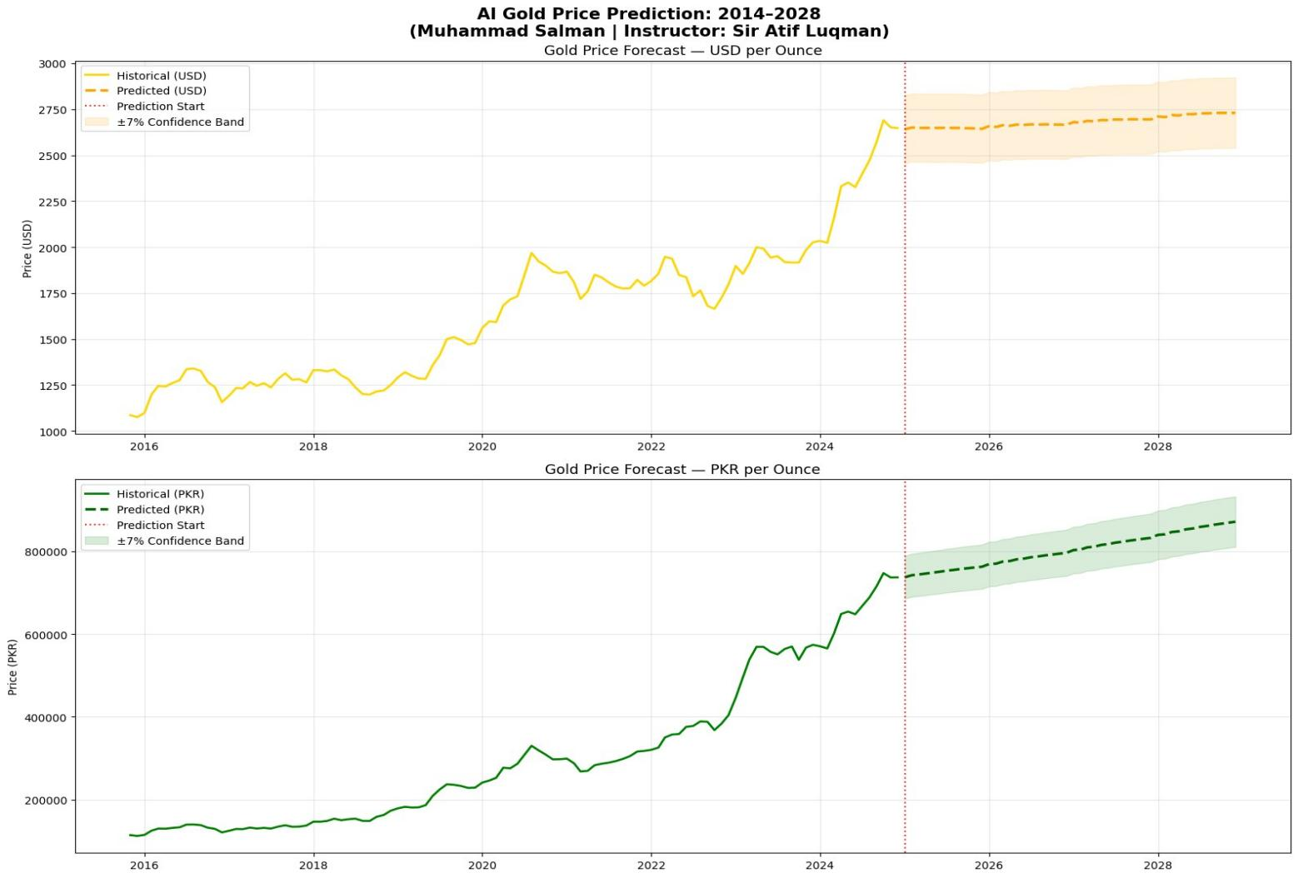
Figure 3: Gold Price Forecast 2014–2028 in USD and PKR (with ±7% Confidence Band)

The forecast shows a moderate and steady upward trend in USD prices, reflecting continued global demand for gold as an inflation hedge. PKR prices rise more steeply due to assumed continued depreciation of the Pakistani Rupee.

8. Database Architecture & Data Storage
The project uses a SQLite database with three tables:

Table | Columns | Purpose
Gold_Prices | Date, Price (USD), Gold_Price_PKR | Historical gold prices (monthly)
Market_Indicators | Date, stock_index, currency_rate, other_factors | S&P 500 and USD/PKR rates
Predictions | ID, Date, predicted_price (PKR) | Future predictions (2025–2028)
Table 5: Database Schema Overview

Predictions are stored with the format (Year-Month, PKR_Price) and cleared before each new prediction run to maintain a single source of truth.

9. Code Structure (9 Blocks)
The project is organized into 9 sequential Python code blocks:

Block | Name | Description
1 | Imports & Setup | Imports all libraries: pandas, numpy, sklearn, matplotlib, sqlite3
2 | Data Loading | Connects to SQLite DB, loads and merges Gold_Prices and Market_Indicators tables
3 | EDA & Visualization | Plots historical gold prices (USD & PKR) and USD/PKR exchange rate; generates correlation matrix
4 | Feature Engineering | Creates time features (Year, Month, Month_Num), lag features (1, 3 months), rolling averages (3, 6 months)
5 | Model Training | Splits data 80/20, trains Linear Regression and Random Forest; evaluates with RMSE, MAE, R²
6 | Future Predictions | Iteratively predicts gold prices for Jan 2025 – Dec 2028 using projected PKR and S&P 500 inputs
7 | Forecast Visualization | Plots historical + predicted prices (USD and PKR) with ±7% confidence bands
8 | Save to Database | Clears old predictions, inserts new forecasts into Predictions table in SQLite
9 | Final Summary | Prints model performance metrics, key price milestones, and confirms output files saved
Table 6: Project Code Block Summary

10. Conclusions & Recommendations
10.1 Key Findings
- Linear Regression (R² = 0.9796) proved superior to Random Forest (R² = 0.9213) for gold price forecasting in this dataset, validating that a strong underlying linear trend exists in long-term gold prices.
- PKR depreciation is the dominant amplifier of gold prices in Pakistan — the model confirms that even moderate USD price increases translate to large PKR price jumps.
- Gold prices in USD are projected to grow moderately from ~$2,690 to ~$2,752/oz over 2025–2028.
- Gold prices in PKR are projected to grow from ~PKR 750,000 to ~PKR 870,500/oz, a 16% increase, primarily driven by currency depreciation.

10.2 Limitations
- The model assumes gradual, linear PKR depreciation (~10 PKR/year). Sudden devaluation events (as seen in 2022–2023) are not captured.
- Geopolitical events, interest rate changes, and oil price shocks — which are major drivers of gold prices — are not explicitly modeled.
- The ±7% confidence band is a heuristic estimate, not a statistically derived interval.

10.3 Future Work
- Incorporate macroeconomic indicators: inflation rates (CPI), Federal Reserve interest rates, and oil prices
- Explore LSTM (Long Short-Term Memory) neural networks for better time-series forecasting
- Add real-time data pipeline using gold price APIs for live prediction updates
- Develop a web dashboard (Flask/Streamlit) for interactive gold price lookup and forecasting

References
1. Pedregosa et al. (2011). Scikit-learn: Machine Learning in Python. JMLR 12, 2825–2830.
2. Hunter, J.D. (2007). Matplotlib: A 2D Graphics Environment. Computing in Science & Engineering, 9(3), 90–95.
3. McKinney, W. (2010). Data Structures for Statistical Computing in Python. Proceedings of the 9th Python in Science Conference.
4. World Gold Council. (2024). Gold Price Historical Data. https://www.gold.org
5. State Bank of Pakistan. (2024). Exchange Rate Archives. https://www.sbp.org.pk
6. Breiman, L. (2001). Random Forests. Machine Learning, 45(1), 5–32.

